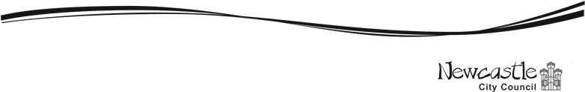
Newcastle City Council April 2026
Proposal for Public Space Protection Order

Questionnaire
1105All feedback and information collected through this consultation will be used to inform the decision-making process, but this does not mean that any proposed measure will automatically be included in the final PSPO. Any conditions introduced must be supported by robust evidence and must demonstrate a clear need, both within the city centre and across the wider city area.
a. But ’idea If you need this information in another format or language, please phone Joseph Catchpole at: or email: Joseph.Catchpole@newcastle.gov.uk

The area covered by the proposed PSPO
Here is the area we are looking at for the proposed PSPO:
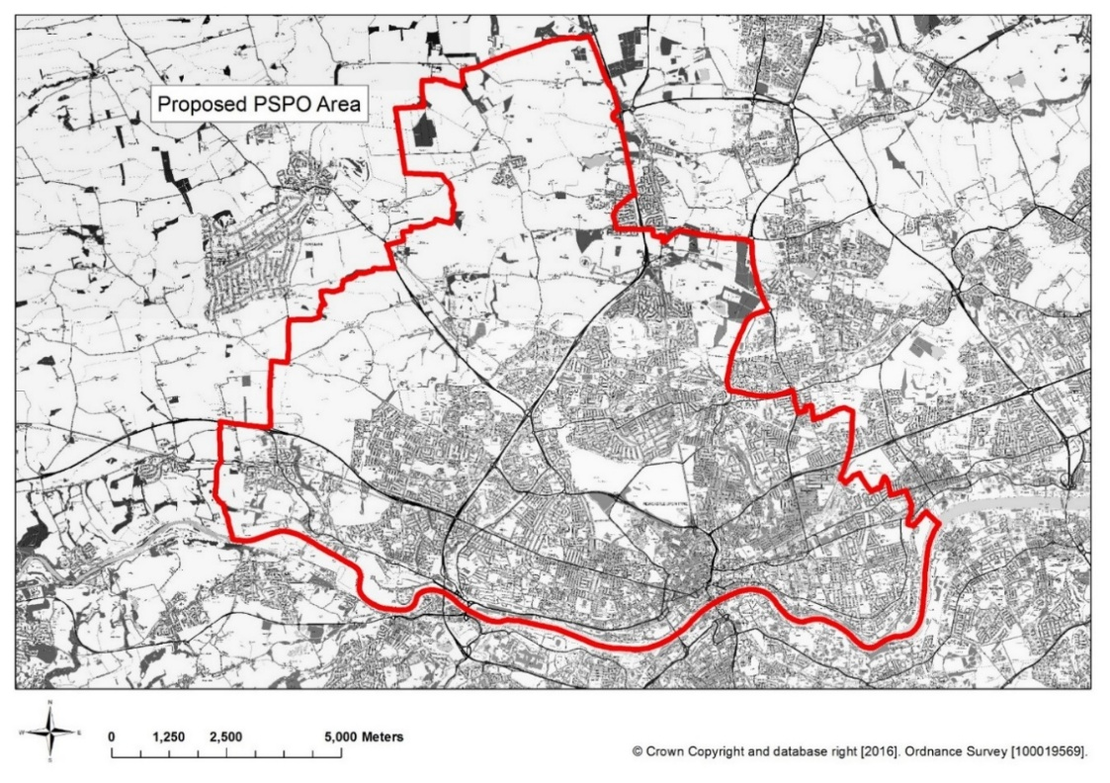

Newcastle upon Tyne: city-wide (image above)

- How often do you visit the proposed restricted area? (i.e. Newcastle upon Tyne)
☐ | Everyday
☐ | Once a week
☐ | More than once a week
☐ | Once a month
☐ | More than once a month
☐ | Rarely
☐ | Never

This form is split into the following sections:
- Section 2 - About the PSPO: a brief overview and the suggested restrictions
- Section 3 – Your final comments and any additional thoughts
- Section 4 – About you

Section 2 has a list of the proposed restrictions and a brief explanation for why we are considering them. Please give us your views by answering the questions about each suggest restriction. Thanks!

Section 2 – About the Public Spaces Protection Order (PSPO): a brief overview and the conditions

Issue A: Drinking alcohol in public places
Reason: Existing PSPO conditions surrounding drinking alcohol in public places are to stop problems like noise, fights, or people causing antisocial behaviour because of alcohol. These rules are not meant to stop normal, peaceful activities. For example, families having a picnic in the park or people enjoying a drink in their own garden.
The new public spaces protection order is meant to have one set of rules for the whole area. The aim is to stop alcohol related behaviour that is upsetting or harmful to local communities.
Those that are causing issues, a person shall stop consuming alcohol or surrender any containers (sealed or unsealed) which are reasonably believed to contain alcohol, when required to do so by an Authorised officer.

- We propose including this behaviour in the citywide Public Spaces Protection Order. Do you agree or disagree with this?
☐ | Strongly agree
☐ | Agree
☐ | Disagree
☐ | Strongly disagree

- Have you ever seen this behaviour happening within the proposed PSPO area?
☐ | Never
☐ | Rarely
☐ | Sometimes
☐ | Frequently

- Does or would this behaviour have a ‘detrimental effect’ on your quality of life? ‘Detrimental effect’ is not defined within the Act, but it means things like include feeling the need to avoid an area, feeling like you are ‘running the gauntlet’ when you are walking around, feeling annoyed, irritated, intimidated or scared.
☐ | No – Never
☐ | Yes – Rarely
☐ | Yes – Sometimes
☐ | Yes – Frequently

- If you replied ‘yes’, please tell us about this:

- Does, or would, this behaviour affect whether you visit or use the proposed restricted area (as shown in the map) above?
☐ | No
☐ | Yes

- Do you have any more comments about this?

Issue B: Dog Control and Dog Fouling
Reason: Dog Control Orders are rules about things like keeping dogs on a lead, not letting dogs go into places where they aren’t allowed and cleaning up dog mess.
Right now, there is one big Dog Control Order that covers the whole council area.
The new PSPO would include all these same dog-related rules, so everything is in one place. This new PSPO would replace the old orders and would let the council take action against dog owners who don’t follow the rules.

- We propose including this behaviour in the citywide Public Spaces Protection Order. Do you agree or disagree with this?
☐ | Strongly agree
☐ | Agree
☐ | Disagree
☐ | Strongly disagree

- Have you ever seen this behaviour happening within the proposed PSPO area?
☐ | Never
☐ | Rarely
☐ | Sometimes
☐ | Frequently

Does or would this behaviour have a ‘detrimental effect’ on your quality of life?
‘Detrimental effect’ is not defined within the Act, but it means things like include feeling the need to avoid an area, feeling like you are ‘running the gauntlet’ when you are walking around, feeling annoyed, irritated, intimidated or scared.
☐ | No – Never
☐ | Yes – Rarely
☐ | Yes – Sometimes
☐ | Yes – Frequently

- If you replied ‘yes’, please tell us about this:

- Does, or would, this behaviour affect whether you visit or use the proposed restricted area (as shown in the map at the start) above?
☐ | No
☐ | Yes

- Do you have any more comments about this?

Section 3 – Final thoughts and comments:

Many thanks for giving us your views, if you have any further comments please use the space below:

- If you have any other comments please write them here:

Section 4 – About you

We would like to ask you some questions about yourself. We will use people’s answers to these questions to help us understand more about whether there are differences between the views and experiences of different people who have taken part in this consultation.

All the information you give will be kept completely confidential and only seen by people taking part in the consultation. We will not share your answers with anyone else, and you cannot be identified from them. You do not have to answer these questions if you do not want to.

- What is your postcode? We are asking for people's postcodes so that we can find out if there are differences in the experiences and views of people living in different parts of Newcastle. We will not use this information for any other purpose.

- How old are you?
☐ | Under 18 |  | ☐ | 65-69
☐ | 18-29 |  | ☐ | 70-79
☐ | 30-39 |  | ☐ | 80-84
☐ | 40-49 |  | ☐ | 85-89
☐ | 50-59 |  | ☐ | 90 and over
☐ | 60-64 |  | ☐ | Prefer not to say

- Do you have any physical or mental health conditions or illnesses lasting or expected to last 12 months or more?
☐ | Yes, and they reduce my ability to carry out day-to-day activities a lot
☐ | Yes, and they reduce my ability to carry out day-to-day activities a little
☐ | No, I do not have this
☐ | Prefer not to say

- What is your sex (as assigned at birth)?
☐ | Female
☐ | Male
☐ | Prefer not to say
☐ | Other – please describe below

- Which of these groups do you belong to?
☐ | Asian or Asian British, including Chinese
☐ | Black, Black British, Caribbean or African
☐ | Mixed or multiple ethnic group
☐ | White or White British
☐ | Prefer not to say
☐ | Another ethnic group, please describe below:

This consultation will close on 11. 05. 2026

Please return this form to :
Safe Newcastle Unit
Newcastle City Council
Civic Centre
Newcastle upon Tyne
NE1 8QH

Thanks for giving us your views!

